**ASSIGNMENT #2**

**LECTUREE: SIR MAJID BASHIR**

**WEB TECHNOLOGIES**

**M.Faaiz Mir 477/FBAS/BSIT/F19**

**Shayan Mehmood 480/FBAS/BSIT/F19**

1) Study 10 different websites/mobile apps and list out their useful features. Focus on the service/utility they offer

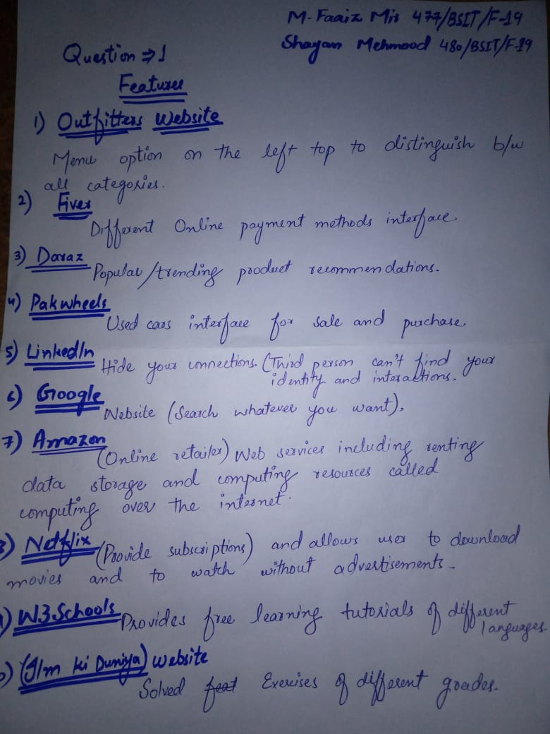

2)  Use the study to identify a PROBLEM that you will be solving through your prospective Web application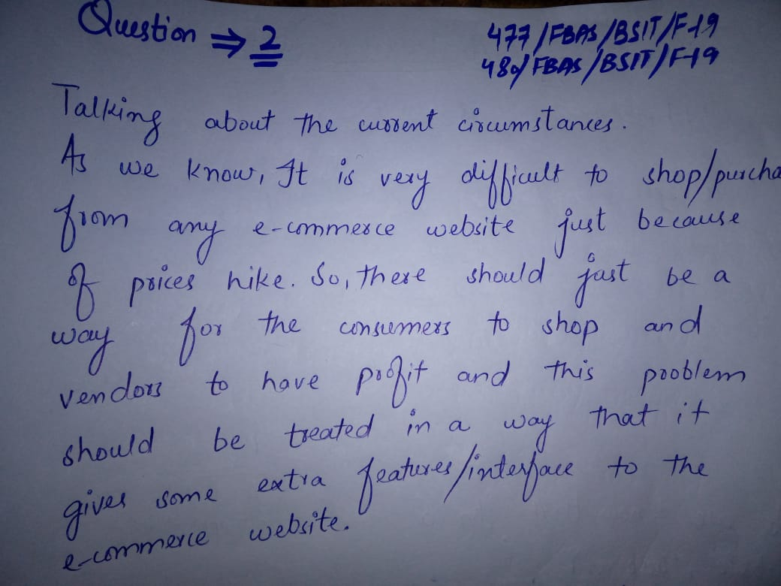

) Propose a web based solution for the identified problem. Present a two page project proposal summarizing the service(s) your prospective web application would provide.